OCEAN PALMS ELEMENTARY SCHOOL



PARENT AND STUDENT HANDBOOK 2026-2027

OPE Motto – Everyday. Everyone. Everything Matters!

Preface
The handbook is designed as a resource with important information regarding school policies and procedures. We hope that you will find this useful as questions or concerns arise throughout the school year and that it will be a meaningful tool for you.

SJCSD Mission Statement
The St. Johns County School District will inspire good character and a passion for lifelong learning in all students, creating educated and caring contributors to the world.

OPE Mission Statement
At Ocean Palms, we inspire students to explore and develop their strengths and passions. We focus on integrity, leadership, and service above self. We commit to fostering a positive, safe, nurturing environment with an emphasis on academic rigor, the arts, athletics, and technology within a vibrant, caring community.
- Our focus is the child.

OPE Vision Statement
Ocean Palms Elementary is where students become leaders:
Lead by example Encourage others Accept challenges Do the right thing Explore their passions Reflect on learning
Strive for academic excellence

TABLE OF CONTENTS

TOPICS | PAGE
School Access – Raptor | 4
Safety Protocols | 7
Arrival and Dismissal Procedures | 8
Bus Transportation | 15
Attendance and Digital Absence Form | 18
Breakfast and Lunch | 19
Medication Policy | 22
Grading and Promotion Requirements | 23
Schoolwide Expectations | 26
Bullying and Harassment | 29
Student Code of Conduct | 30

SCHOOL ACCESS

Access to Our School
For the safety of all students and staff, all visitors must be approved through the St. Johns County School District’s volunteer application process in order to enter the school building during school hours, beyond the front office. This is a district-wide policy supported by the Raptor Visitor Management System, which helps monitor and track all campus visitors.

Previously Approved?
If you were previously approved in the district’s former system, your status has been transferred, and you are still approved. You do not need to reapply at this time. You can always call the front office at 904-547-3760 to check your status.

Who Needs School Access?
You must be an approved volunteer to do any of the following during the school day:
- Volunteer in the classroom
- Attend class parties, celebrations, or performances
- Chaperone or attend field trips
- Eat lunch with your child
- Participate in parent-teacher conferences during school hours
- Visit any part of the building beyond the front office

Don’t Wait – Get Approved for School Access Now!
The Raptor Visitor Management System is managed at the district level not by the school. That means we are unable to expedite or override the approval process. If you're not approved before the event you want to attend, you will not be permitted on campus. No exceptions.

How to Get Approved:
- Complete the Volunteer Application at www.stjohns.k12.fl.us/volunteer
- Your name must match your driver's license or state-issued ID exactly
- The application includes a criminal background check and sex offender screening
- Once approved, you will receive an email confirmation
- The approval process may take 2–6 weeks, so please apply early
Encourage all family members who may want to visit or attend school events to complete the application in advance. No exceptions can be made to allow access without approval even for visiting friends or relatives.

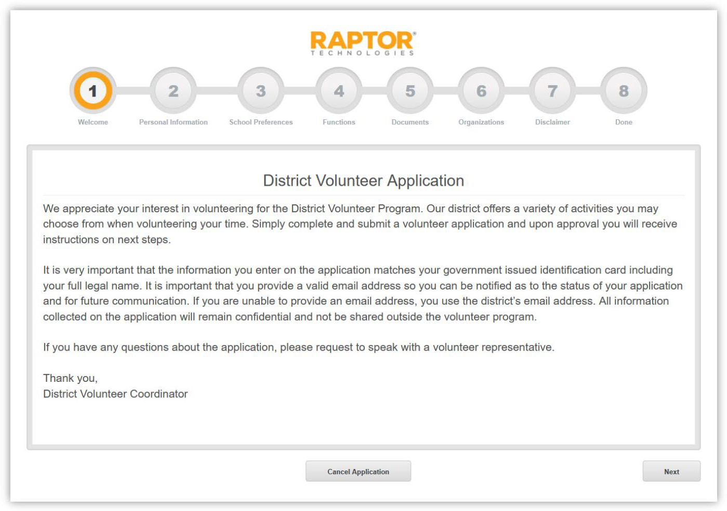
Once approved, you’ll receive a congratulatory email confirming your school access status. See screenshot below.
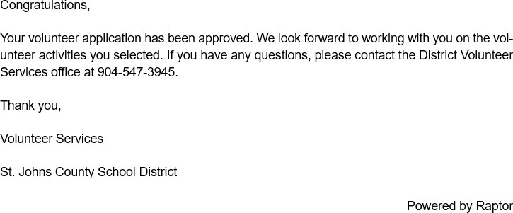
All approved visitors must:
- Sign in through the Raptor system at the front desk
- Present a valid driver’s license or state-issued ID (no expired IDs)
- Wear the printed Visitor or Volunteer Badge at all times while in the building
- Sign out and return the badge before leaving campus

Only the following forms of ID will be accepted:
- A current state-issued driver’s license
- A current state-issued ID card (from the Department of Motor Vehicles)
If you do not have a Social Security number or have a visa, contact the district's Volunteer Services Department for alternate steps.

Keeping Your Information Up to Date
It is essential that we have current contact and emergency information on file.
- To update phone numbers or emergency contacts, contact Brittany Johnson at Brittany.johnson@stjohns.k12.fl.us
- Only the guardian who registers the student can add or delete emergency contact information
- To update your address, visit: https://www.stjohns.k12.fl.us/student/enrollment/#forms

Home Access Center (HAC) for K–5 Parents
https://www.stjohns.k12.fl.us/hac/
The Home Access Center (HAC) provides parents with secure, password-protected access to important information about their child’s education. Through this web-based system, you can view:
- Attendance
- Report cards
- Schedules
- Assessment data
HAC is part of our district’s eSchoolPlus Student Information System. To get started, please complete the Home Access Center User Registration form, available on the district’s website. If you experience any issues creating your account, please contact: Brittany Johnson, Computer Operator- Brittany.johnson@stjohns.k12.fl.us

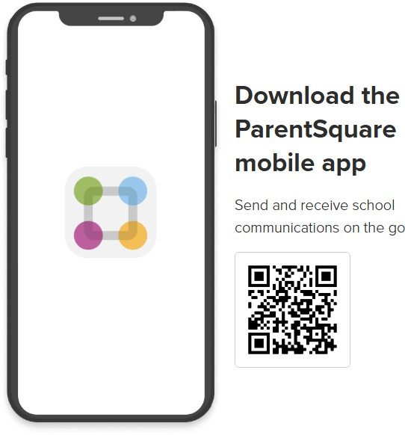
ParentSquare – Mass Communication System
How to Get Started:
- Go to: www.parentsquare.com/signin
Use the email or phone number you provided to the school when you registered.
- Download the free app
Search “ParentSquare” in the App Store or Google Play
- Sign in and customize your notifications and language settings
- You choose how often to receive notifications: Choose to receive information as it comes or all at once with a daily digest at 6 p.m.

SAFETY PROTOCOLS

Emergency Drills
To ensure the safety of all students and staff, our school conducts monthly emergency drills in accordance with district policy. Drills include fire evacuations, lockdowns, severe weather (high wind) procedures and bus evacuation drills (district-mandated). Students are taught to follow our Always Rules during all drills and emergencies. Practicing a variety of scenarios helps prepare students to respond calmly and appropriately. Safety is always our top priority.

Single Point of Entry and Locked Doors
To maintain a secure campus, our school follows a Single Point of Entry protocol:
  - The staff parking lot and bus loop gate remain locked during the school day.
  - All perimeter and playground gates are locked unless supervised by a staff member.
  - All exterior doors to the building are locked throughout the day.
  - During arrival and dismissal, designated staff monitor exterior entry points.
  - All visitors must check in at the front office and be approved volunteers before entering any area beyond the lobby.
  - All classroom and interior doors remain locked during the instructional day.
We appreciate your cooperation in helping us maintain a safe and secure environment for all students.
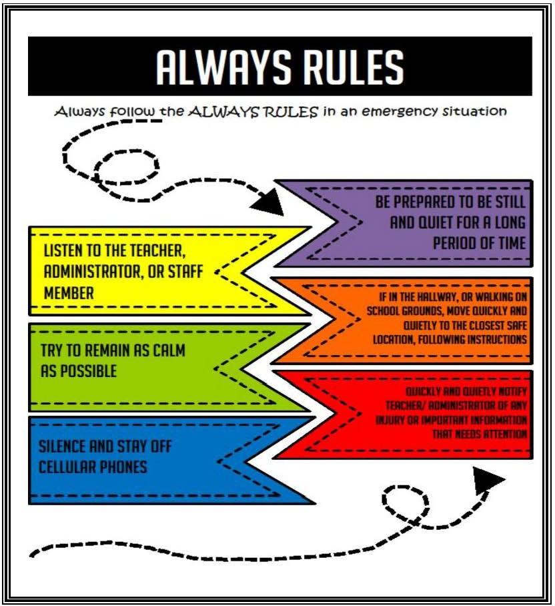
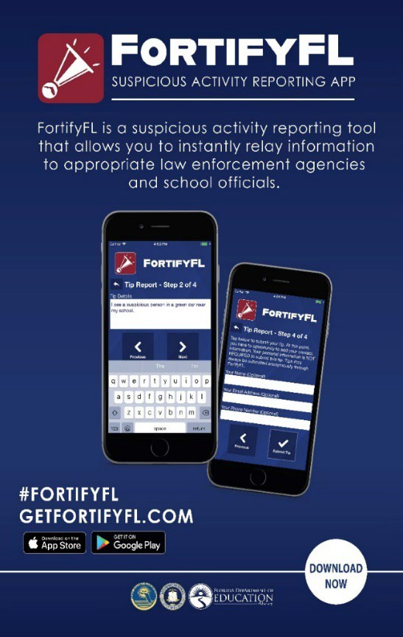

ARRIVAL AND DISMISSAL

Car Tags Required for Parent Pick-Up (PPU)
Each family should have received two Parent Pick-Up car tags for afternoon dismissal.
  - Display your tag clearly by hanging it from the rearview mirror or placing it on the dashboard so it’s visible from a distance. 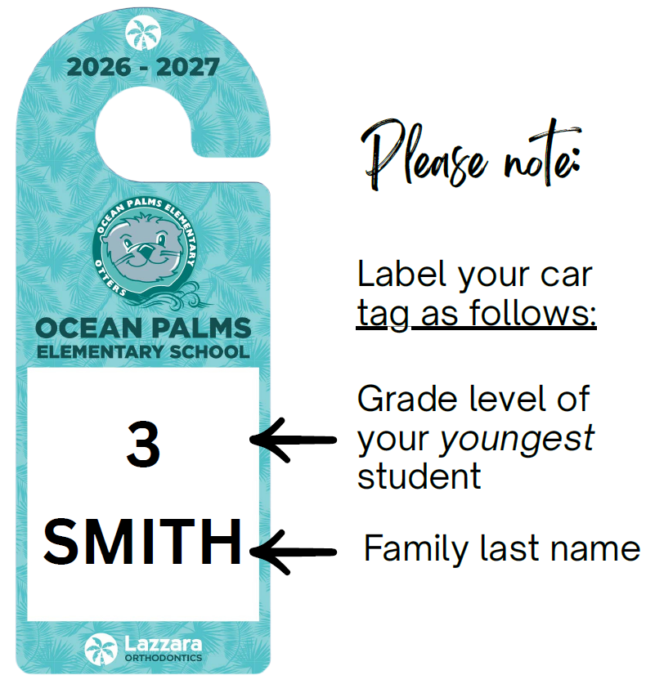

  - Write your child’s grade level (youngest sibling) at the top and their first and last name(s) underneath.

  - Older siblings will meet and wait in the younger sibling’s designated pick-up area.
  - For safety, students may only enter vehicles from the passenger (sidewalk) side.
  - For liability reasons, our staff will not buckle students. If they need assistance, pull into the parent parking lot.

Forgot Your Car Tag? Here's What to Do:
If you or the authorized person picking up your child do not have a Parent Pick-Up car tag, you will be directed to pull forward to the very front of the car line, where a staff member will meet you.
  - A photo ID will be required.
  - The staff member will contact the front office to verify authorization for pick-up.

  - Alternatively, you may park your vehicle and go into the front office with your photo ID

Arrival Procedures
Ocean Palms staff begin supervising students at 8:00 a.m. Instruction begins promptly at 8:25 a.m.

  - Students arriving before 8:00 a.m. must be enrolled in the Before-Care program (unless attending a scheduled club meeting).

  - Adults should remain in their vehicle in the car line.
  - Students must exit the vehicle from the passenger (sidewalk) side only.
  - Please refrain from using cell phones unless utilizing a hands-free device.

  - After drop-off, merge carefully into the left lane to exit. Cars in the right lane are actively unloading, so use caution and yield when necessary.
Otter Support Zone – Required Assistance Area
Ocean Palms proudly serves all students, including those who require physical assistance or additional supervision during arrival and dismissal. If your child is in PreK, VPK, Ms. Hays, Ms. Johnston, or Ms. Crouch’s room, please drop off in the designated "Otter Support Zone" at the front of the car line.
Staff will be available to:
  - Assist your child in and out of their car seat or vehicle
  - Escort your child safely to and from class

Transportation Changes
All students will receive a blue luggage tag on their backpack identifying their standard mode of dismissal.
To make a change complete the Transportation Change Form by 12:00 p.m. on the day of the change.
https://www.parentsquare.com/feeds/83092496
Teachers do not check their email regularly during the school day.

Early Dismissal Changes
All parents of students who have appointments or need to be checked out early will use this Early Dismissal Change Form:
https://www.parentsquare.com/feeds/83092446

- The form needs to be completed by 10:00 AM on the day of the early dismissal.
  - 2:00 p.m. on Monday, Tuesday, Thursday, Friday
  - 1:00 p.m. on Wednesdays
No students will be dismissed from the office after these times.

Dismissal Procedures
  - Dismissal for VPK and K-5 begins at 2:45 p.m. (1:45 p.m. on Wednesdays). Transition to dismissal locations begins inside the building at 2:35 / 1:35 to ensure all students move safely and are accounted for.
  - Dismissal for Pre-K and students in Ms. Johnston, Ms. Hays, and Ms. Crouch’s classes will be at 2:35. These students and their siblings will be dismissed at the hallway where the science lab doors are in the bus loop. Please walk to these doors with your ID so that they can be safely escorted and released to guardians.
  - Students will not be called out of class to wait in the front office. To minimize lost instructional time, they will be called only when the authorized individual has arrived and signed in.
  - Students will be released only to a guardian listed in our system. A photo ID is required.

  - For safety, all students must load on the passenger (sidewalk) side of the vehicle.

Car Rider Traffic Reminders
  - Use caution when entering and exiting the parking lot. Watch for pedestrians and oncoming traffic.
  - If traffic backs up on Landrum Lane, please wait your turn and use the correct entrance lane.
  - Out of courtesy, cars entering from both directions take turns entering the lot.

  - Do not use the exit lane to enter the parking lot.
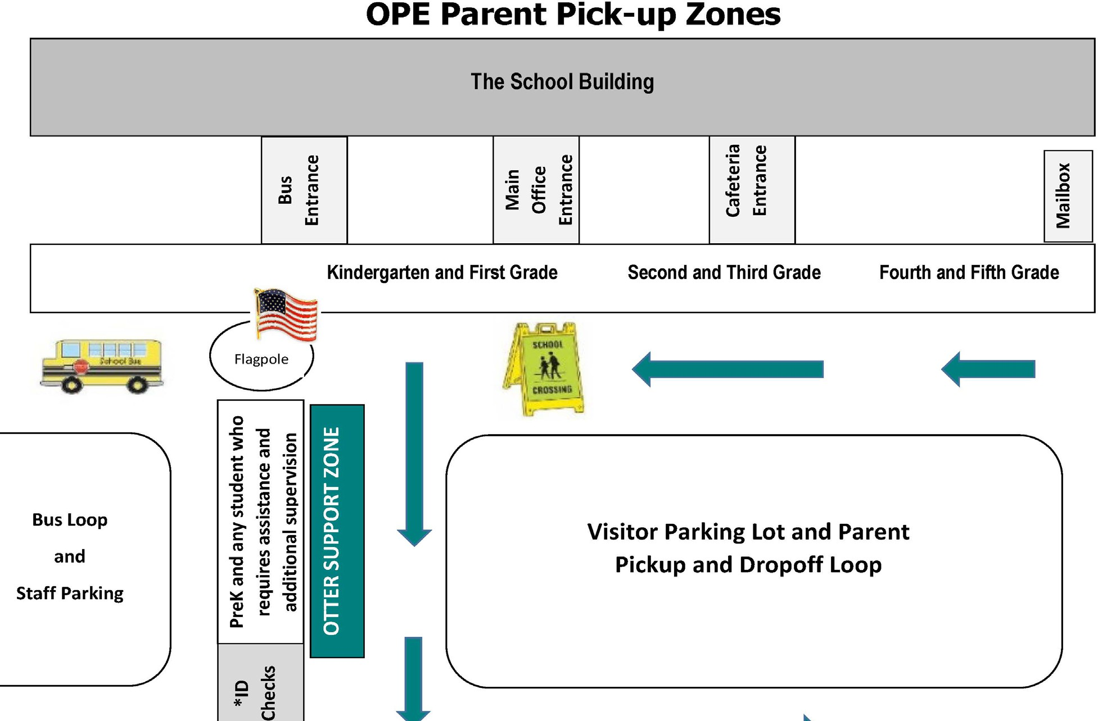
VPK

Before and After School Care: The D.E.N. (Develop, Enrich, Nurture)
Ocean Palms offers before and after school care through our Extended Day program for students in grades K–5.
    - Morning care begins at 7:00 a.m. | After-care ends at 6:00 p.m.
    - Activities include academic support, arts & crafts, and recreation.
    - For enrollment details, visit: https://www-ope.stjohns.k12.fl.us/extendedday/
    - Mrs. Kim LaMondie, Extended Day Coordinator E-mail - kim.lamondie@stjohns.k12.fl.us

Biker/Walker Procedures
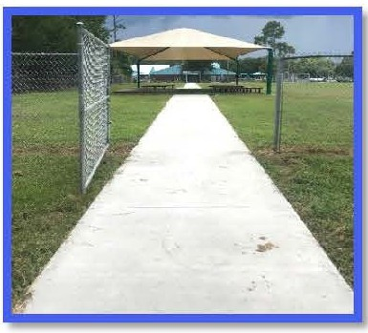
Biker/Walker Permission Form
Students must have a completed Biker/Walker Permission Form on file before they are allowed to leave campus as a biker or walker. This form must be submitted to the front office and is available on our school website: www-ope.stjohns.k12.fl.us

Arrival (8:00 - 8:25 a.m.)
      - Biker/Walker students should enter through the designated gate located near the front field canopy between 8:00 and 8:25 a.m.
      - The biker/walker gate is for student use only during arrival and dismissal. All parents must check in through the front office if entering the school campus.
      - The gate will be locked at 8:25 a.m. Late arrivals must be escorted to the front office by a parent for check-in.
      - In accordance with Florida Statutes (F.S. 316.2065 and 316.20655), students riding bicycles, e-bikes, or scooters must wear a safety helmet.
      - For safety reasons, students must walk their bikes, e-bikes, scooters to the bike rack once they enter school grounds.

Dismissal (2:45 p.m. I 1:45 p.m. on Wednesdays)
- An authorized adult must be present at the biker/walker gate to receive the student unless a parent has provided written permission on the biker/walker form for the child to walk or bike home independently.
- In the event of lightning at dismissal, biker/walker students will be held at school and must be picked up through the Parent Pick-Up line by an authorized adult. A text alert will be sent to all families notifying them of the dismissal change.
- Please do not park on the grass along Landrum Lane to drop off or pick up students. If you are unable to meet the requirements for your child to be a biker/walker, please use the parent drop-off/pick-up line or enroll in our Extended Day program.


Biker/Walker Permission Slip
Please complete this form and return to school.

Student's Name: Teacher/Grade: Parent's Name: Address of destination: Route traveled by student (please list street names): _

To ensure the safety of our students, it is required to have this form signed and returned to school before stu-dents are released at the biker/walker gate. Students must check out with the staff member stationed at the gate before leaving campus. Once students exit the biker/walker gate, parents/guardians assume full responsibility for their student. Please note crossing guards are not present on Landrum Lane or Palm Valley Rd. to assist students. Students are not permitted to bike/walk on S. Roscoe Blvd. In the event of lightning at dismissal all biker/walker students will be held at school for parent pick up. A School Messenger text message will be sent to alert you of the procedure change. Again, this is only if lightning is detected at dismissal.

( ) Allow my student to pass through the biker/walker gate without an adult. ( ) Hold my student at the biker/walker gate until received by an adult.
Authorized adults to pick up student at the gate (Photo ID is required at the gate).

Full Name: Full Name: Full Name:

Parent/Guardian Signature Date
13

BUS TRANSPORTATION

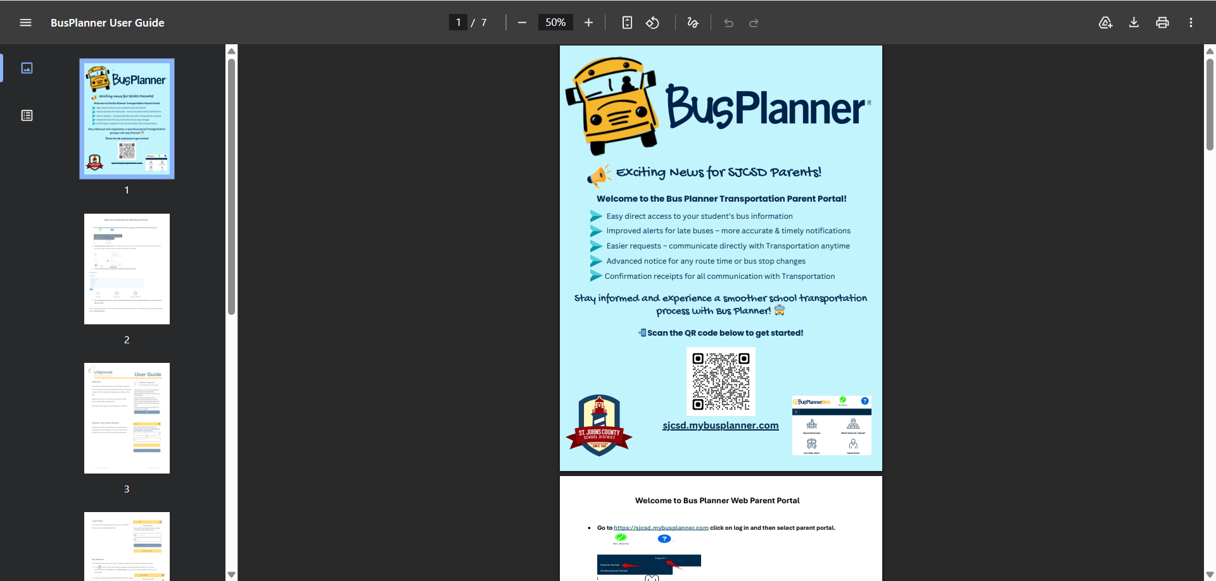
BusPlanner & Chipmunk App: Accessing Your Child’s Transportation Information
All school transportation details will be available exclusively through BusPlanner and the Chipmunk app. This new system replaces the Home Access Center (HAC) as the source for your child’s bus information.

BusPlanner is an online parent portal that provides:
- Easy access to your child’s assigned bus stop, route number, and pick-up/drop-off times
- Real-time updates and alerts for route changes or delays
- Direct communication with the St. Johns County Transportation Department
- Confirmation receipts for submitted requests or updates

The Chipmunk app is the mobile companion to BusPlanner, allowing families to receive the same information and alerts on their smartphones for added convenience.
- Important: Bus route information is no longer posted on HAC. Families must use BusPlanner or Chipmunk to access and stay updated on transportation details.

We strongly encourage families to create their accounts prior to this date to avoid delays in accessing schedules. Visit: https://sjcsd.mybusplanner.com or scan the QR code on the BusPlanner flyer or download the Chipmunk app in your device’s app store.
- For support, contact: Tiffany Bravo, Routing Specialist Email: tiffany.bravo@stjohns.k12.fl.us

Bus Regulations
Students are given the privilege of using the services of the St. Johns County School District (SJCSD) for transportation to and from school as well as to and from field trips. Standards of discipline must be maintained at all times in order to satisfy safety requirements. Whenever a driver must direct his/her full attention away from the road, danger exists. No student will be allowed to endanger the other students on the bus. Parents are not to board the bus at any time. A complete list of bus regulations is available in the Student Code of Conduct.
- Loading at Schools
All kindergarten age student riders will load district school buses at schools in advance of all other students. Early loading will afford school bus operators and school staff sufficient time to account for kindergarteners as they board buses and assist kindergarteners with putting on their seatbelts.
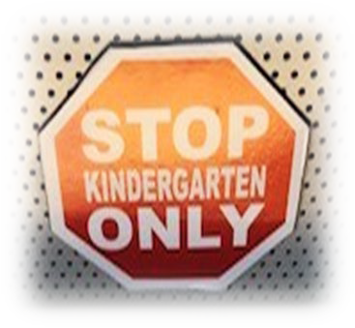
- Kindergarten Seating
Operators will seat all kindergarten age students in the kindergarten zone designated by the red and white stop sign magnet. Kindergarteners may not move to another location in the bus to sit with siblings. The kindergarten zone is the area closest to the operator’s seat.

- Unloading at Bus Stops
  - For safety and security reasons, school bus operators are directed to only discharge pre-kindergarteners/kindergarteners at a bus stop when the parent/guardian is physically present at the student door of the school bus to receive the student.

  - If a school bus operator does not see the parent/guardian at the student door of the bus, they are instructed to keep the pre-kindergartener/kindergartener aboard the bus and contact dispatch by radio.

  - If a parent or guardian requires a pre-kindergartener/kindergartener to disembark a bus with an older sibling or to be met at the student door of the bus by anyone other than the parent/guardian, an approved provisional transportation waiver is required from Transportation. Reference the PTWP link under quick links of the school district homepage.

- School Orientations
At the beginning of each school year, all bus operators will attend elementary school and K-8 school orientations at their respective assigned schools. The intent for having buses and operators present at orientations is to familiarize kindergarteners with their respective buses and operators. Additionally, the event will afford operators, kindergarten age student riders, and parents/guardians an opportunity to meet each other.

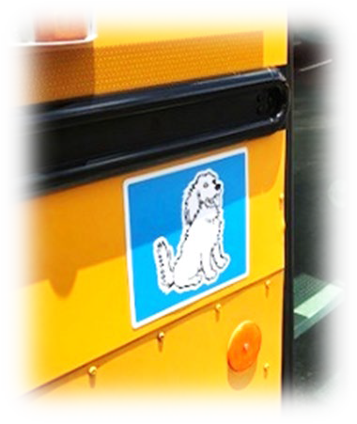
- Color and Animal Coded Backpack Tags and School Bus Magnets: Transportation will prepare color/animal coded tags for the backpack top handles of all kindergarten age student riders. The bands are color/animal
coded to the respective buses. The tags are exceedingly durable and will
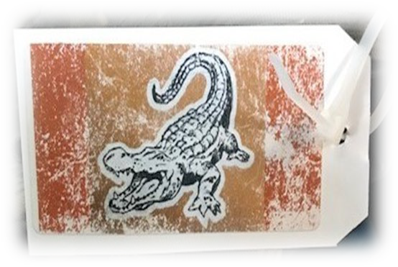
include the bus stop information for the student. To assist in correlating the bands to buses, Transportation will apply rectangular and circular color/animal coded magnets to the front and rear of buses as shown in the pictures.

ATTENDANCE POLICY
Attendance
Regular attendance is important; however, the health and safety of our students and staff is our number one priority. Here are some guidelines from the Student Code of Conduct when a child should possibly stay home:

- Fever of 100.4 or greater
- Chills
- General tiredness or not feeling good
- Frequent congested (wet) or croup-sounding cough
- Lots of nasal congestion with frequent blowing of nose
- Vomiting (even just once)
- Diarrhea
- Stomach pain that is accompanied by repeated vomiting or diarrhea. Note: if you child complains of stomach pain for several days, your should call your doctor for advice.
- Symptoms of cold or flu

When Absent
Our excused absence form is located on our school webpage https://www.parentsquare.com/feeds/83092542

A parent or guardian will submit their child’s absence using the digital form within forty-eight (48) hours of returning to school, stating the cause of the absence. After fifteen (15) days of absence, whether excused or unexcused, a student must present verification from a licensed doctor for all subsequent absences due to illness. Doctor’s notes need to be uploaded to the secure form.

Excused absences include personal illness, illness of an immediate family member, death in the family, religious holidays of the student’s established religious faith, required court or law agency appearances, school/district related competitions, and scheduled doctor or dentist appointment.

Unexcused absences include shopping trips, pleasure trips, suspension from school, appointments without prior approval except in case of emergency, truancy.
For the SJCSD to be in compliance with state statues and the Department of Education they must notify parents of their children’s absences and state laws. The school district sends automated attendance communication to parents/guardians when a student is absent.

In addition, communication is also sent when a student has reached 5, 10, and or 15 absences, whether excused or unexcused. When a student has reached 15 total absences the district requires a doctor’s note for additional absences to be excused.

For a complete list of excused and unexcused absences, students and parents should refer to the Student Code of Conduct or visit the district’s website www.stjohns.k12.fl.us/student/attendance/ .

Tardiness
School begins at 8:25 a.m. Any student reporting to school after that time is tardy. Any tardy student must be accompanied by a parent or guardian to the front office. Students will receive an admittance slip, before reporting class. Students who need assistance will be escorted to their classrooms.

BREAKFAST AND LUNCH

Breakfast and Lunch
Students eating breakfast will report directly to the cafeteria to eat. PreK and VPK students will eat breakfast and lunch in their classrooms. Students will eat lunch with their class at their designated tables. For safety, students are not permitted to leave their table or the cafeteria without permission.

Birthday and Party Treats, Snacks, and Invitations

Guidelines and Protocols for Student Birthdays and Classroom Celebrations

*Note new District Allergy-Aware Food Protocols
To support the health and safety of all students:
- Non-food celebrations are strongly encouraged for birthdays, holidays, and special events.
- Examples of acceptable non-food birthday recognition include:
  - Birthday books donated to the classroom
  - Stickers, pencils, or other small trinkets
  - Special recognition during morning announcements
  - Classroom activities or games
  - Certificates or birthday crowns
- When food is proposed for a classroom celebration, all applicable requirements outlined in these protocols and guidelines must be followed.

Protocols for Classroom Food Activities, Parent Notification, and Permission
Prior to any classroom event, celebration, curriculum activity, or reward involving food:
- Teachers must provide parents/guardians with at least 2 weeks advance notice through ParentSquare or another district-approved communication platform.
- The notice must identify the exact food items to be offered, including:
  - Exact Food being provided
  - Brand name (when applicable)
  - Date and reason for the activity
3. All food provided in the classroom must be commercially prepared and store-bought. Homemade foods, foods prepared in private residences, and foods without original packaging are not permitted.
4. All food items must remain in their original packaging and include a nutrition facts label and ingredient list.
5. Parents/guardians must complete the district-approved permission form indicating whether their child is authorized to participate in the food activity.
6. Only students with a signed parent/guardian permission response authorizing participation in the specific food activity may consume the foods provided.
7. Permission granted for one activity does not constitute permission for future activities. Separate notification and permission shall be required whenever different food items are offered.

8. Parents must provide an approved alternate food item for their child if they do not give their child permission to participate in the planned classroom food activity.
Food Allergies
If your child has food allergies, please provide the school nurse with a physician’s note indicating the allergies and appropriate medical attention required. We also discourage students from sharing food because of food allergies.

Lunch Payments
Prepayments to your child’s meal account with a debit or credit card can be made through Paypams. Log on to https://paypams.com/ to set up your account. Payment can also be received by the food service manager in form of check or cash during your child’s lunchtime. If a check is used, please indicate the student’s full name on the check in the memo section. Prepayment is encouraged as it assists in the movement of students through the line. Free and reduced applications can be completed at https://www.stjohns.k12.fl.us/food/free/

Meal Prices
- Breakfast $1.75 and Lunch $3.25
- The application for Free and Reduced Meals will be posted on the district webpage in early August.

A La Carte Items
Ocean Palms provides several a la carte items in the cafeteria. These items include choices such as baked chips, pizza, Gatorade, juices, frozen fruit bars and ice cream. These items range in price from $0.30 to $2.50 and are not included in the free and reduced meal program.

Refunds and Parental Restrictions
Refunds are addressed at the school level and require a written request. Restrictions can be placed on your student’s meal account with a written request. Once restrictions are placed, they can only be removed by the parent or guardian in a written letter/email to the food service manager, Ms. Trish Williams - 547-3771, Latrecia.Williams@stjohns.k12.fl.us.

Pre-pay School Meals at .paypams.com or using the PayPams Mobile App


paypams

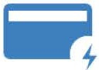
Pay Now

Account Balance

�
�
Automatic Payments

Email Notifications

Add/Remove Students

ffl
Payment History

Cafeteria Purchases
I CURRENT USERS TIPS FOR THE BEGINNING OF THE SCHOOL YEAR
Login to the site at least one week before the beginning of the school year. Check that your credit/ debit cardon file has not expired,your email address is updated,and that your automatic payment plan's stop date has not expired
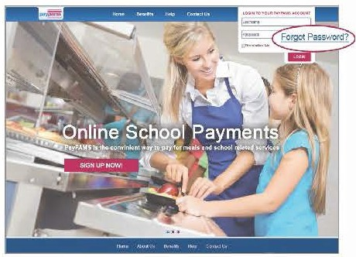
Forgot Password: If you previously registered with PayPAMS but forgot your password, go to PayPAMScom, click 'Login' then click on the 'Forgot Password' link. If you were unable toretrieve your password through the'Forgot Password' link, contact customer support from the 'Contact Us' page Donot register again Note passwords are case sensitive.
Balance Transfer from Year to Year: Any remaining student meal account balance will automatically transfer to the next school year.
Important note: If your child moved from one school to another within the same school district,it may takea day or twofromthebeginning of theschool year to transfer theremainingbalance from the old school to the new school.During that timeperiod,thebalanceon PayPAMS may show as $0.00. If you are not sureif your child's account had a remainingbalance from the previous school year, we recommend youmake a payment
Refunds: PayPAMS processes refunds only for the exact payment amount If the student has already used some of themoney, or has graduated, please contact the school district
Moved to a different school district: If you moved to a different school district, you can keep the same username and password information.Logintoyour account,go to 'Contact Us' andselect subject 'Moved from District'. Do not register again Note PayPAMS cannot transfer money from one school district to another. Contact your previous school district for refunds.

I NEW USERS SIGN UP NOW
- Go to PayPAMScom and click on the'Sign Up Now!' button on thehome page
- Select your state, then select your school district.
- Create a username and password and enter your contact information.
- Add children toyour account.
- Make payments or set up automatic payments based on lowbalance.

I HELPFUL TIPS WHEN REGISTERING
- Username: Create a unique username. If the system indicates that the username is taken, select a different username.
- Duplicate Accounts: If the system indicates that an account already exists with the same phone number or email address,contact customer support from the 'Contact Us' page.
- Meal Account Balance and Cafeteria Purchases: It takes 1-2 school days before balances and cafeteria purchases information for new registrants can be displayed. However, you can make payments immediately upon registration. If you cannot view balances two days after you added the student to theaccount,contact customer support from the 'Contact Us' page.

' I ,
,.

- •,- Helpful Tips for using www.paypams.com
I PAYMENTS
- Posting Payments: It takes one to two school days for a payment to replenish your child's account at the school cafeteria Your balance on PayPAMS website will reflect your recent payment only after the school cafeteria confirms receipt of payment
- Payment Confirmation: When a payment is processed, a confirmation number will be displayed and an email will be sent verifying that the payment was processed If a confirmation number is not displayed, the payment was not processed
- Declined Payments: If your payment is declined, verify that all billing information is correct If all information is correct and payment is still declined, contact the issuing credit card company for further information Reasons a card can be declined: insufficient credit/funds in account, incorrect billing information entered, closed credit card account, or credit card expiration date.
- Payments for the same student from two separate accounts: To prevent duplicate accounts, PayPAMS allows associating a student to only one account If both parents/guardians cannot share the same username and password, contact customer support from the 'Contact Us' page
- Convenience Fees: Depending upon the school district, a nominal convenience fee may be charged to cover the cost of processing payments and maintaining the website. To check if your school district charges a convenience fee, please click 'Sign Up Now!' on the PayPAMS homepage, then select your state and school district
- Credit Card Types: PayPAMS accepts both credit and debit cards. When registering, please check which cards your district accepts
- Credit Card/ Bank Statement: PayPAMS payments will show up on your credit card/bank statement as payments to 'PayPAMScom', or 'PAMS-<your school district> CO'
- Payments at the School Cafeteria: For questions regarding cash or check payments submitted directly at the school cafeteria, please contact the school cafeteria directly Do not contact PayPAMS

I LOW BALANCE EMAIL NOTIFICATIONS
- Email Notifications: To make sure emails from PayPAMS are not blocked, add customerservice@paypams com to your address book and safe list
- Change of Email address: If you change your email address be sure to update your user profile on PayPAMS
I LOW BALANCE AUTOMATIC PAYMENTS
- Low Balance Automatic Payments Trigger: PayPAMS recommends triggering automatic payments when the student meal account balance falls below $12.00. Having a lower 'minimum balance' when setting up Automatic Payments may not allow enough time to replenish your child's account
- Automatic Payment Confirmation: If you sign up for Automatic Payments, you will receive an email confirmation of the payment, including current balance.
- Declined Automatic Payment: Your automatic payment will not be processed if the card was updated, declined, expired, or if the 'Stop Date' that was set initially has passed
I CAFETERIA PURCHASES
While PAMS displays cafeteria purchases, we do not regulate what the children are purchasing or eating For questions regarding purchases at the cafeteria, contact the school cafeteria directly Student Activity is only displayed from the day the student was added to PAMS. Data is available for 90 days
I COMO REGISTRARSE
l En PayPAMScom haga clic el bot6n de 'jlnscribete Ahora!' en la Pagina de lnicio.
- Seleccione su estado y distrito escolar
- Cree un Usuario y contrasena e introduzca su informaci6n de contacto
- Anadir ninos a su cuenta

lPREGUNTAS?
Haga clic en 'Help' en la pagina inicial de PayPAMS.com


I NEED ASSISTANCE?
Please visit PayPAMS.com and click 'Help' to navigate
to PayPAMS Help Center!
KEEP THIS FOR REFERENCE
USERNAME PASSWORD

MEDICATION POLICY

Florida Statute 1006.062 authorizes school personnel to assist students in the administration of prescription medications. Parents/Guardians are encouraged to administer medications at home prior to or after school hours. The schools do not keep stock medicine in the clinic.

If your child needs medication during school hours, please note the following:

- All medications (prescription and over-the-counter) must have a medication form signed by both the parent/guardian and the physician ordering the medication.

- All medications must be received in the original container with current Rx label including student’s name, dosage, frequency of administration, physician’s name, and expiration date of medication (the expiration date on the pharmacy label, not on the medication box, will be the expiration date). Over-the-counter medications must be in the original, unopened container.

- Medications must be brought to school by parent/guardian. Please do not send any medications with your child in their backpack. Medications may not be brought to school by the student.

- Medication brought to school by a student will be kept in the clinic until a parent/guardian comes to the school with the required paperwork. Without the required authorization, the student will not be given the medication during school hours.

- Medications should not be transported between home and school daily. Separate containers should be kept at home and at school.

- At the end of the school year, parents are responsible for picking up their child’s medication.

The St. Johns County School nurses provide a vital service for our students. If you have any questions or concerns, please do not hesitate to contact Health Services at 904-547-7693.

GRADING AND PROMOTION REQUIREMENTS

Instructional Continuity Plan
The SJCSD created an instructional continuity plan for all teachers to follow in the district curriculum maps but are expected to adjust pacing in response to student learning. Please visit the SJCSD “Families Page” for the Year-At-A-Glance documents for each grade and class: https://www.stjohns.k12.fl.us/year-at-a-glance/.

Promotion Requirements
The promotion requirements for students in St. Johns Public Schools can be found in detailed form in the St. Johns County School District Student Progression Plan at http://www.stjohns.k12.fl.us/cs/spp.

Report Card Marks
Promotion in grades K-2 is based primarily on progress in reading. Students must make satisfactory progress in the English Language Arts State Standards to be promoted. Each student’s reading progress toward grade level reading achievement is indicated on their report card as an M, P, or I (see chart below).
(K-2) Report Card Marks
Description | Percentage Represented
Meeting Standards (M) | 85-100
Progress Towards Standards (P) | 70-84
Improvement Needed (I) | 69 and below

(3-5) Report Card Marks
Grade | Percentage Represented
A | 90-100
B | 80-89
C | 70-79
D | 60-69
F | 0-59

Grading Overview
All students are guaranteed a rigorous and appropriate curriculum regardless of their assigned teacher. Grade level teachers use common standards based assessments, review student data, teaching strategies, and share students to provide appropriate interventions and enrichments throughout the school year.
Grades for all students are located within Home Access Center. For more information on HAC, please go to https://www.stjohns.k12.fl.us/hac/. HAC provides parents or guardians and students with access to view the student’s report card and standardized test scores.

Quiz or Common Formative Assessment (CFA)
  - Students will not study for a quiz or formative assessment. These types of assessments include reading passages with questions, workbook exercises, classwork, essay drafts, reflections, project steps and guided notes.
  - Cover a strategic “chunk” of information.
  - A CFA provides important information to the teacher about what learning challenges students are facing during the learning sequence.
  - CFA’s shall be administered Monday-Friday without advance notice. These are not materials that require a study guide or study time.
  - Teachers utilize CFA’s to give timely feedback and indicators to students about where they are in relation to the mastery of the current learning standard prior to the summative assessment.
- Weighted 30% (for grades 3-5).
- All students on a grade level are given identical CFA’s (grades K-5).
- Retesting is not offered for grade recovery on CFA’s.
- Students will not be marked lower than 50% if they fail to reach proficiency.
- Incomplete or missing work is shown in the gradebook as “INC” until the work is completed. At the end of quarter, INC’s will become 50%.

Test or Common Summative Assessment (CSA)
- Covers a unit of study. Example CSA’s - tests or final projects.
- Weighted 70% (for grades 3-5).
- All students on a grade level are given identical CSA’s (grades K-5).
- Students and parents will receive advance notice and an opportunity to study (when appropriate) before a CSA is administered.
- CSA’s shall not be administered on Mondays.
- If a grade of 75% or higher is not earned, reteaching/remediation and grade recovery are available (for grades K-5).
- Students will receive the highest score earned for grade recovery per SJCSD guidelines.
- Grade recovery is shown in the gradebook as a decimal point with the new score (ex. original score was a 62, grade recovery was 75, the final score would be 75.62).
- Students will not be marked lower than 50% if they fail to reach proficiency.
- Incomplete or missing work is shown in the gradebook as “INC” until the work is completed. At the end of quarter, INC’s will become 50%.

Homework
The amount of homework given has a smaller effect size on student achievement in elementary school versus middle school or high school, with a gain of about six percentile points (Marzano, 2001). Homework helps younger students develop study skills and become responsible for their learning at home and school.
When assigning homework, teachers will ensure students are provided with sufficient information and direction to complete the homework assignment independently, and that the assignment is not excessive for its intended purpose.
- Homework shall not exceed 30 minutes nightly, in grades (K-1).
- Homework shall not exceed 45 minutes nightly, in grades (2-5).
- Homework shall not be assigned over holidays and weekends.
- Projects shall not be assigned as homework.

- Teachers will monitor homework and provide feedback, but homework is not taken for a grade in the gradebook.
- Recess or teacher led PE shall not be taken away for incomplete or missing homework.
- We do not interrupt class for homework deliveries. All homework delivered to the school will be placed in the teacher’s mailbox to be retrieved at his or her convenience.

SCHOOLWIDE EXPECTATIONS
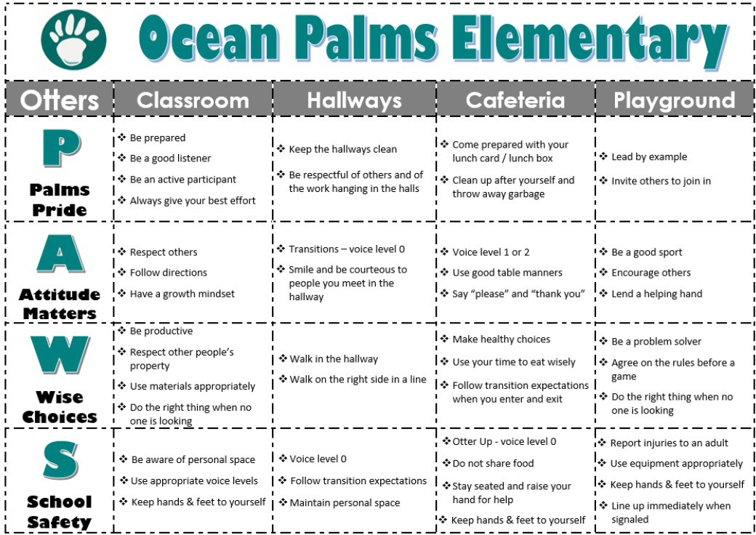
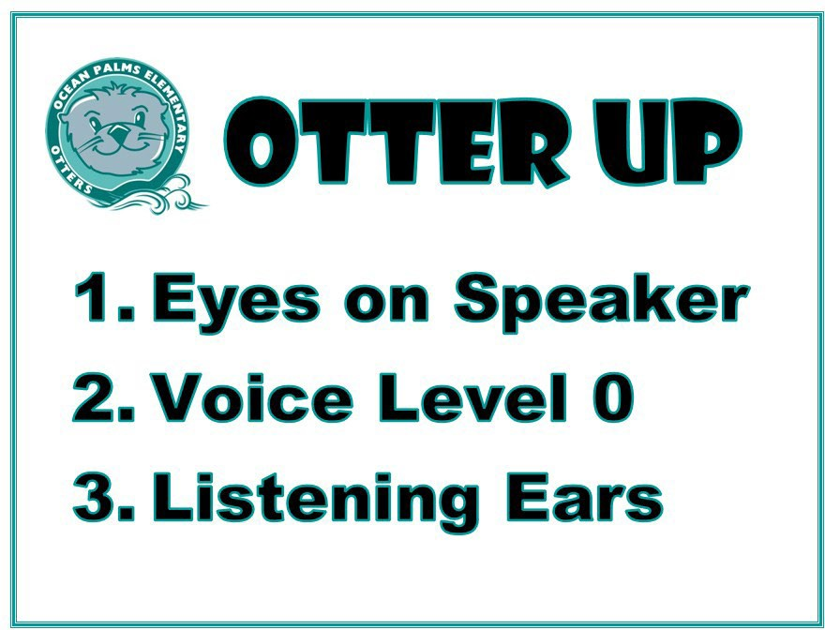
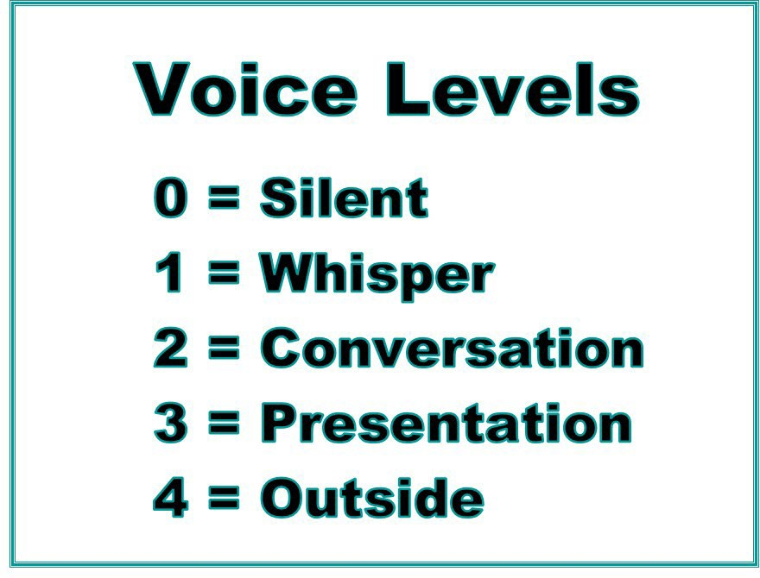

Positive PAWS and the Otter Outpost
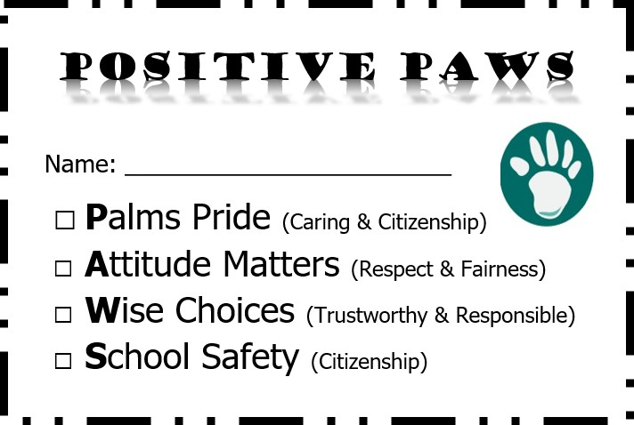
- This acknowledgement is based on students earning PAWS for demonstrating school-wide expectations. All staff will carry Positive Paws to hand out to students who are observed following the expected behaviors.
- Students will submit their Positive Paws to their homeroom teacher. Every Friday homeroom teachers will draw 1 student to visit the school store “Otter Outpost”.

100 Class Compliments

- All staff members are encouraged to compliment classes for following school wide expectations.

- The teacher and class will track class compliments and select an appropriate award every time the class earns 100 compliments.

Character Counts
In 1998, the St. Johns County School District, along with area businesses, youth organizations and civic groups, selected the national character education program of CHARACTER COUNTS! as a countywide initiative to instill positive character traits in our young people. Character education is an important part of every School Improvement Plan, a major component of each Student Code of Conduct and our Strategic Plan. This program is used throughout the district. There are 6 pillars: trustworthiness, respect, responsibility, fairness, caring, and citizenship. One student from each class will be recognized and celebrated in an assembly at OPE based on each pillar.

Classroom Behavior Management Policy
Ocean Palms Elementary believes in the Positive Behavioral Intervention and Supports (PBIS) philosophy. Classroom expectations and behaviors shall be taught and modeled to all students.
Introducing, modeling, and reinforcing positive social behavior is an important step of a student’s educational experience. The purpose of school wide PBIS is to establish a climate in which appropriate behavior is the norm and recognized.
We expect all students to follow our school-wide behavior expectations and to conduct themselves appropriately. Each teacher shall have a classroom behavior management plan in place to address these issues in a fair and consistent manner.

PAWS Leveled Behavior System
Ocean Palms’ staff will intervene to curtail misconduct. On the rare occasion when a student violates a rule our staff will follow the leveled behavior system outlined below. This system is based on the St. Johns County School District’s Student Code of Conduct, and it applies to all Pre-kindergarten through fifth grade students.

Level I Offenses:
Level I offenses are relatively minor acts of misconduct that interfere with the orderly operation of the classroom, a school unction, extracurricular/co-Curricular program or approved transportation. A student who commits a level I offense may also be subject to criminal proceedings.
Infractions include:
- Classroom disruption
- Disorderly Conduct
- Disrespect
- Dress Code
- Failure to Report for Detention
- False and/or Misleading Information
- Insubordination
- Misconduct on School Bus or School Approved Transportation
- Repeated Misconduct
- Tardiness
- Unauthorized Absence from School or Class
- Physical Contact after misconduct
- Public Display of Affection
- Violation of Separate Sex Group Bathroom Policy
- Other – any other minor act of misconduct which interferes with the orderly operation of the classroom, the school program, a school function or activity, an extracurricular activity or approved transportation.
Level II Offenses:
Level II offenses are acts of misconduct that are more serious or disruptive than offenses in Level I. Level II also includes repeated acts of Level I misconduct, and acts directed against people or property that do not seriously endanger the health or safety of others. A student who commits a Level II offense may also be subject to criminal proceedings.

Infractions Include:
- Cheating/Plagiarism
- Cell Phone and Wireless Communications Devices
- Destruction of Property (under $10)
- Disrespect
- Altercation
- Forgery
- Gambling
- Insubordination
- Intimidation/Threats
- Profane, Obscene, or Abusive Language/Materials
- Repeated Misconduct of Level I offenses
- Stealing
- Unauthorized Assembly and/or Publications
- Verbal Confrontation
- Leaving Campus Unauthorized
- Unauthorized Use of Technology
- Unauthorized Possession of Non-Prescription Medication
- Other – any other intermediate act of misconduct or any more serious, harmful or disruptive than any of the offenses described in Level I.
Note: Descriptions of all Level I and II offenses can be found in the Student Code of Conduct beginning on p. 30, followed by Levels III – V offenses.

BULLYING AND HARASSMENT

Bullying and Harassment
St. Johns County School District believes all students and employees be afforded a setting that is safe, secure, and free from bullying and harassment of any kind. In compliance with Florida Statute 1006.147 and School Board Rule 3.21, the school district has adopted a comprehensive policy prohibiting bullying and harassment.

Definition of Bullying
For behaviors to be labeled as bullying, all three of the following components must be present:
- The behavior is repeated
- The behavior is intentional
- There is an imbalance of power

Meeting the School District Definition of Bullying
The school level investigation will determine if all three components are present, and the behavior meets the school district’s definition of bullying written in our policy. The St. Johns County School District’s policy prohibiting bullying and harassment defines bullying as systematically and chronically inflicting physical hurt or psychological distress on one or more students.

Incidents of bullying or harassment can be reported to the school as follows:
- In person at the school
- In writing to the school
- By phone to the school
- If bullying is reported anonymously, please provide enough details for school staff to investigate.

The following are charts to help distinguish bullying from other behaviors.

Rough Play | Fighting | Bullying
Usually friends; often will do the same things again | Usually not friends; Typically, not repeated | Not friends but will be repeated
Power not an immediate Issue | Power close to equal | Power is not equal
Not about hurting | Trying to hurt each other | Bully is trying to hurt, humiliate
Affect is friendly, mutual | Affect is negative, angry | Affect varies between the victim and bully

Conflict | Bullying
Equal power (not trying to take something from someone) | Unequal (or imbalance) of power (want to take power or possessions from someone)
Happens occasionally | Repeated negative actions
Accidental (not pre-planned, in the heat of the moment) | Intentional (Premeditated, on purpose, planned)
Equal emotional reaction (both genuinely upset) | Emotional harm on just one (person being bullied is more upset)
Remorse | No remorse – blames target
Effort to solve problem | No effort to solve problem

Joking | Teasing | Becomes Bullying
No malicious intent. | It is innocent in motive. | It is a choice to hurt someone.
Kidding with a friend. | Mutual banter. Allows the teaser  and the person being teased to swap roles with ease. | It is based on an imbalance of power and one-sided.
Kindred joking. | Maintains basic dignity of everyone involved. | Humiliating, cruel, demeaning comments disguised as jokes.
If it bothers the person who is the target of the joke, the joker will show respect and stop. | It is discontinued when the person being teased objects to the teasing. | Includes fear of further bullying and continues when target becomes distressed or objects.

STUDENT CODE OF CONDUCT
H T T PS: //WW W.S T J O HN S .K12. FL. U S/ SC H OO L SE RV ICES/CON DUCT/

Student Dress Code
The primary responsibility for a student’s attire resides with the student and their parent/guardian.
The St. Johns County School District expects students to dress in a way that is appropriate for
the school day or any school sponsored event. Student dress code requirements reflect fair, equitable, and consistent practices for all students, while contributing to a safe and positive school climate.
In accordance with statutory requirement F.S. 1006.07 (students are prohibited from wearing clothing that exposes underwear or that exposes body parts in an indecent or vulgar manner)
enforcement will focus on positive guidance without embarrassment to the student and should not disrupt the educational process.

Student Dress Code Summary
- Clothing must be appropriate and cover from armpit to mid-thigh. Tops need straps and must cover the midriff.
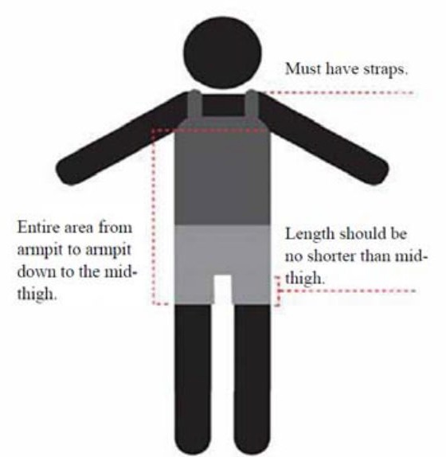
- No clothing, accessories, or piercings may display profanity, violence, drugs, alcohol, tobacco, sexual content, or discriminatory messages.
- Pajamas, bedroom slippers, and gang-related graffiti or symbols are not allowed.
- Ripped clothing above mid-thigh must not show skin.
- See-through or mesh clothing must be layered with opaque clothing underneath or over.
- Hats, caps, bandanas, and sunglasses are not permitted indoors unless approved for medical or religious reasons. Sunglasses and hats may be worn outside.
- Footwear must be safe and appropriate for school.

Cell Phones & Electronic Devices
- Students may bring phones and wireless devices to school but must keep them off and stored during the school day.

- Elementary and middle school students may not use phones or devices during the school day, per House Bill 1105.

- High school students may use devices only if approved by administration (e.g., between classes or lunch) and never during instructional time unless a teacher allows it for educational use.
- Earbuds may not be used during the day unless approved. For safety, only one earbud may be used when not directly supervised.
- Violations may result in the device being taken away. Repeated misuse may lead to discipline or loss of device privileges at school.
- Inappropriate use includes (but is not limited to):
  - Texting, calling, or browsing during unauthorized times
  - Recording audio or video without permission
  - Taking photos without approval
  - Sexting
  - Violating the privacy or rights of others

Instructional Technology Devices
- Students may use devices like laptops or tablets only with permission and for classroom learning.
- Devices must be turned off and stored when not in use.
- Misuse may lead to confiscation and discipline under the Student Code of Conduct.

Search and Seizure
- If a student is suspected of misusing a device or breaking school rules, school administration may review the phone's content as part of the investigation.

Videos, Photos & Recordings on Campus
- Students, parents, and visitors may not take videos or photos on campus, including in the cafeteria or during school-sponsored functions, unless it's a public event such as Fall or Spring Family Night.
- This rule helps maintain a safe, respectful learning environment and protects student privacy.
- Recording devices must remain off during the school day unless explicitly approved.
- The school carefully reviews all photos shared publicly to ensure they comply with parent privacy preferences. Not all families want their child’s photo posted online.
Anyone wishing to use personal electronic equipment on campus must complete a Waiver for Personal Electronic Property, approved and signed by school administration.

Items Not Allowed at School
- Animals: Only approved service animals are permitted.
- Toys: Toys, especially toy weapons, are not allowed and may result in disciplinary action.
- Sports gear & equipment: Lacrosse sticks, bats, wheelies, rollerblades, etc., are not permitted on campus.

Lost & Found
- Label all clothing, lunchboxes, and backpacks with your child’s full name.
- Lost items like lunchboxes and jackets are kept in the cafeteria Lost & Found.
- Smaller items (e.g., glasses or jewelry) are placed in the front office.
- Unclaimed items are periodically donated to local charities.

